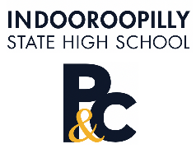
Indooroopilly State High School
Parents and Citizens Association

Proposed Initiative for 2025 – Information for submission
As part of our planning for the 2025 year, please submit an idea or initiative that you'd like to implement via the P&C.
Please remember that the objectives of the Association are to promote the interests of, and facilitate the development and improvement of, Indooroopilly State High School. Operational matters (eg teaching & learning, resources allocation, education delivery) are the school's responsibility.
Also consider whether your idea aligns with the school's strategic plan presented at the October P&C meeting principal by Mick Hornby. This gives us a clear scope and direction for where the school is heading.
On completion of this form, please email to secretary@ishspandc.org.au .We'll then share an outline of ideas and initiatives at the November meeting for consideration by the P&C membership.

Idea / Initiative for 2025: Replace the italics with a title for your idea
Provide a short outline of your proposal.

Funding / P&C Support:
Outline the funding/P&C support you would need to get this idea happening.

